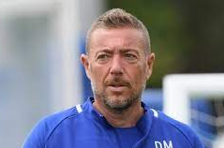  Davide Mazzotta  MR.DAVIDEMAZZOTTA@GMAIL.COM  (+39) 3405051018
  LANGUAGES
  - Italian - Native
  - English - Advance
  LICENSE
  UEFA A
  Italy 2019
  EMPLOYMENT HISTORY
  HEAD COACH
  Malta Football Association MFA
  dal 26 Set 2022 al 31Dic 2022
  1ST ASSISTANT HEAD COACH
  Malta Football Association MFA
  Jan 2020 - to present
  ASSISTANT COACH & FOOTBALL SCOUTING
  Chelsea Football Club, London
  Jul 2017 - 2019
  U17 HEAD COACH
  U.S. Lecce
  Serie C
  Jul 2016 – Jun 2017
  FOOTBALL SCOUTING
  FIGC A, Italy
  Jul 2015 – Jul 2016
  ASSISTANT COACH & FOOTBALL SCOUTING
  SSC Bary S.p.a.
  Serie B
  Jul 2014 – Jun 2015
  ASSISTANT COACH & FOOTBALL COACH
  Spezia Calcio
  Serie B
  Dec 2013 – Jun 2014

